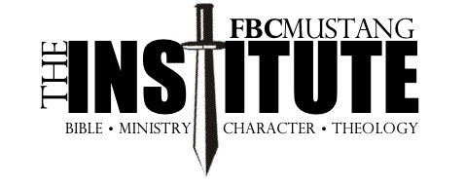

Frequently Asked Questions:

What is The Institute?
The Institute is a two-year training program for men who desire to grow in their knowledge of God and His Word. There are eight classes that cover four categories: Bible Knowledge, Ministry, History, and Theology.

What Courses Will I Take?
Old Testament 1&2, New Testament 1&2, Church History 1&2, Personal Evangelism, Hermeneutics

What is Required for a Course?
Each of the two years has four courses. Courses will involve watching online lectures, reading, and in-person teaching sessions. A Final Exam is taken at the end of these courses.

Do You Have to be a Member of FBC Mustang?
You do not have to be a member to participate. We have graduates and current students from numerous churches.

What is the Cost?
The tuition is $360 per year, which is due with your registration no later than May 1, 2026. For Year Two, the cost is $360 and is due May 1, 2027.

How Do I Sign Up?
Sign Up will be available beginning March 8. Enrollment forms will be in the church office and at the Ministry Connection. You need to turn in your Enrollment form and the tuition of $360 to be registered. The registration deadline is May 1.

Want more information?
We will have an interest meeting for any man wanting to participate in The Institute on Sunday, April 26, at 4 pm in the Fellowship Center.

Program Overview
Year One
- May – August 2026 The Life of Christ
- September – November 2026 Hermeneutics
- December 2026 – January 2027 Church History
- February – April 2027 Old Testament 1

Year Two
- May – August 2027 New Testament 1
- September – November 2027 Old Testament 2
- December 2027 – January 2028 Personal Evangelism
- February – April 2028 New Testament 2

