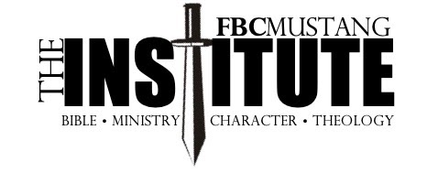

Frequently Asked Questions:

What is The Institute?
The Institute is a two-year training program for men who desire to grow in their knowledge of God and His Word. There are eight classes that cover four categories: Bible Knowledge, Ministry, Godly Character, and Theology.

What Courses Will I Take?
Old Testament 1&2, New Testament 1&2, The Life of Christ, Personal Evangelism, Character of a Leader, Hermeneutics

What is Required for a Course?
Each of the two years has four courses. Each year, three courses will involve watching online lectures at your pace, reading, and in-person teaching sessions. A Final Exam is taken at the end of these courses. One course per year (the Winter course) does not have online lectures or a Final Exam.

Do You Have to be a Member of FBC Mustang?
You do not have to be a member to participate. We have graduates and current students from numerous churches.

What is the Cost?
The tuition is $360 per year, which is due with your registration. For Year Two, the cost is $360 and is due May 1, 2025.

How Do I Sign Up?
Sign Up will be available beginning March 3. Enrollment forms will be in the church office and at the Ministry Connection. You need to turn in your Enrollment form and the tuition of $360 to be registered. The registration deadline is May 1.

Want more information?
We will have an interest meeting for any man wanting to participate in The Institute on Sunday, April 21, at 4 pm in the Fellowship Center.

Program Overview
Year One
- May – August 2024 The Life of Christ
- September – November 2024 Hermeneutics
- December – January 2025 The Character of a Leader
- February – April 2025 Old Testament 1

Year Two
- May – August 2025 New Testament 1
- September – November 2025 Old Testament 2
- December – January 2026 Personal Evangelism
- February – April 2026 New Testament 2

2026 Graduation Graduation Banquet and Graduation Sunday TBD

