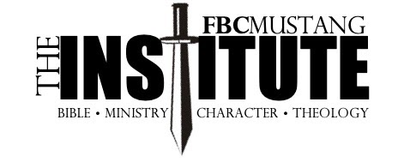

COMMITMENT REGISTRATION
**To register, turn in this form along with $360 tuition for Year One **

Name _______________________ Email _________________________ Cell ________________

Year One
- May – August 2024 The Life of Christ
- September – November 2024 Hermeneutics
- December – January 2025 The Character of a Leader
- February – April 2025 Old Testament 1

Year Two
- May – August 2025 New Testament 1
- September – November 2025 Old Testament 2
- December – January 2026 Personal Evangelism
- February – April 2026 New Testament 2

2025 Graduation Graduation Banquet and Graduation Sunday TBD

Costs
- Year One – $360 (due with your Registration form no later than May 1, 2024)
- Year Two – $360 (due by May 1, 2025)

Expectations
1. As a Christian
- Be in the Word daily (do not substitute reading about the Bible for reading the Bible itself)
- Live a life worthy of the calling as a Christ-follower

Please sign your name if you are willing to commit to these expectations: ______________________________

2. As a student in the Institute
- Complete all assigned lectures and reading
- Attend all meetings possible
- Turn in all homework on time

Please sign your name if you are willing to commit to these expectations: ______________________________

3. As a church member
- Faithfully attend worship
- Find opportunities for service within the church
- Financially support the ministries of the church
- Live as a Great Commission church member

Please sign your name if you are willing to commit to these expectations: ______________________________

